

COURSE: Certified Ethical Hacking

Lecturer: Hummayun Raza Shakoor

Lab Name: Footprinting and Reconnaissancе

Prepared by: Shucayb salad said

Perform Footprinting Through Internet Research Services
Task 1: Find the Company's Domains, Subdomains, and Hosts using Netcraft and DNSdumpster
Step1: I used Netcraft lookup to identify the company’s domains and hosting details.
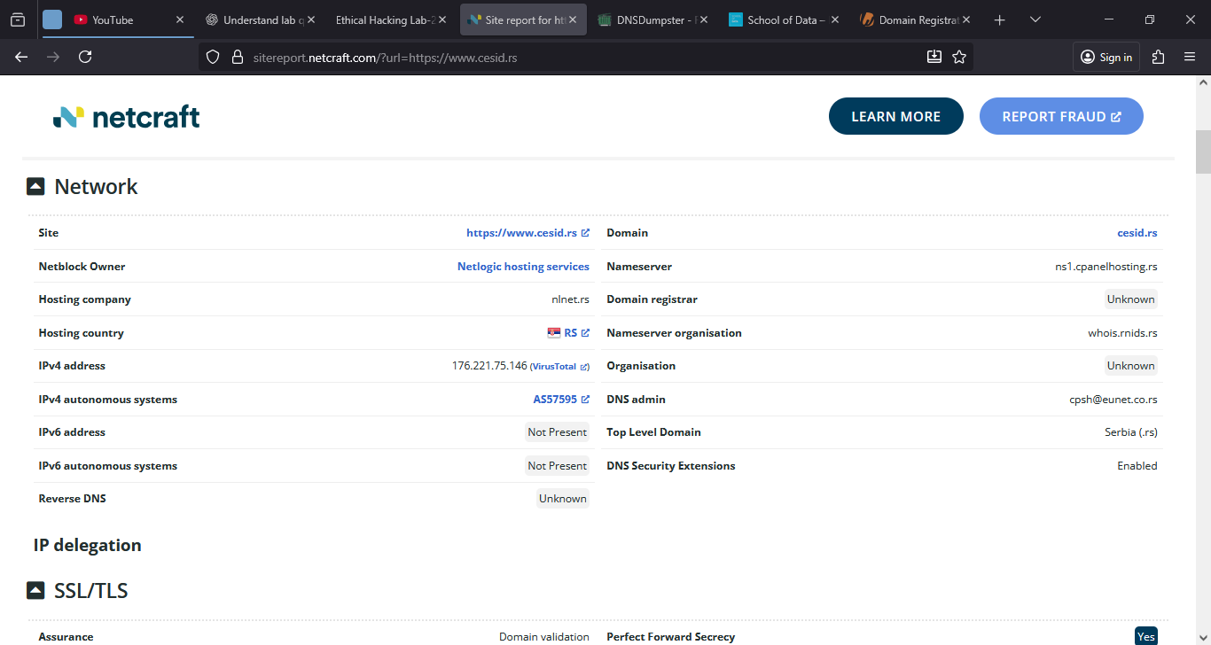
Step2: this is DNS Dumpster map which reveals domain records and subdomain as well.
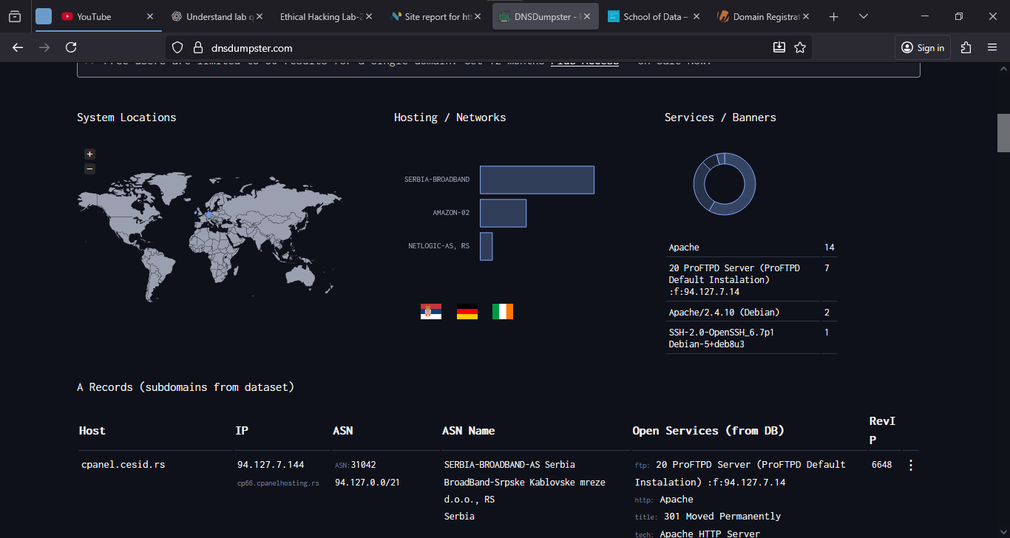

Step3: this is the detailed DNS record list from DNSDumpster for the target domain.
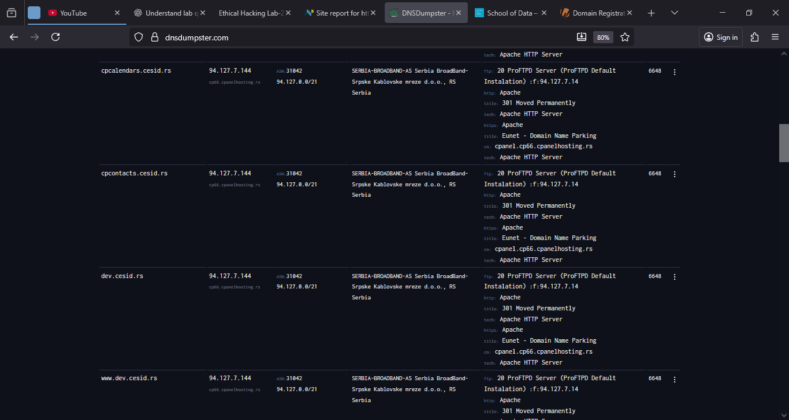
Perform Footprinting Through Social Networking Sites
Task1: Gather Personal Information from Various Social Networking Sites using Sherlock.
I used Sherlock search to gather public usernames and profile links for a site member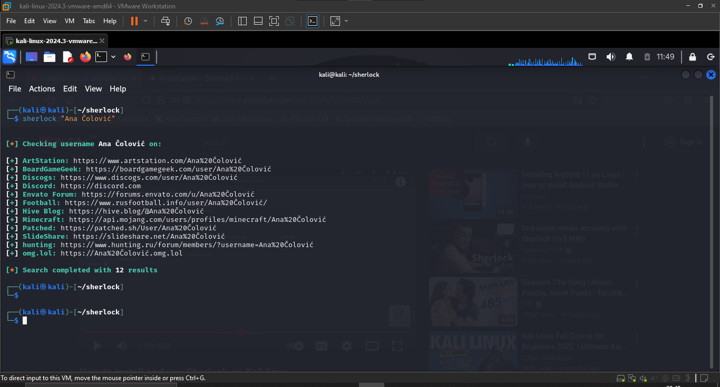
Perform Whois Footprinting
Task1: Perform Whois Lookup using DomainTools
Step1: I used DomainTools WHOIS to show registrar, registration date, and name servers.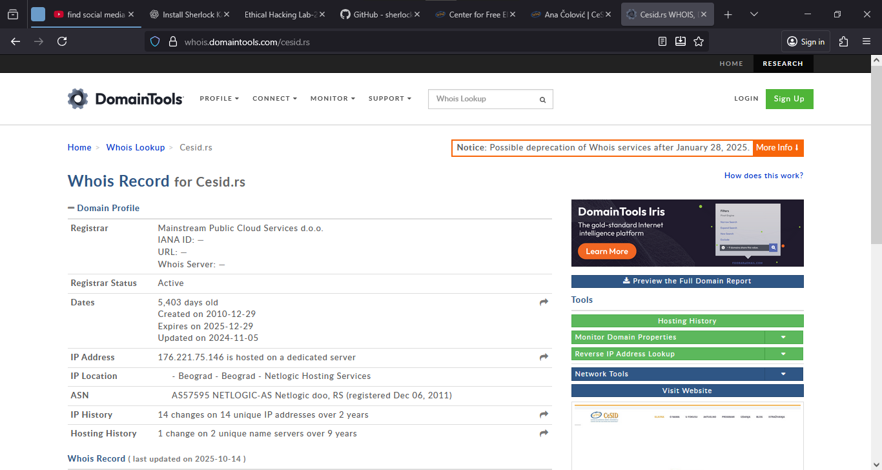

Step2: This is more detail about IP address, hosting provider, and contact info
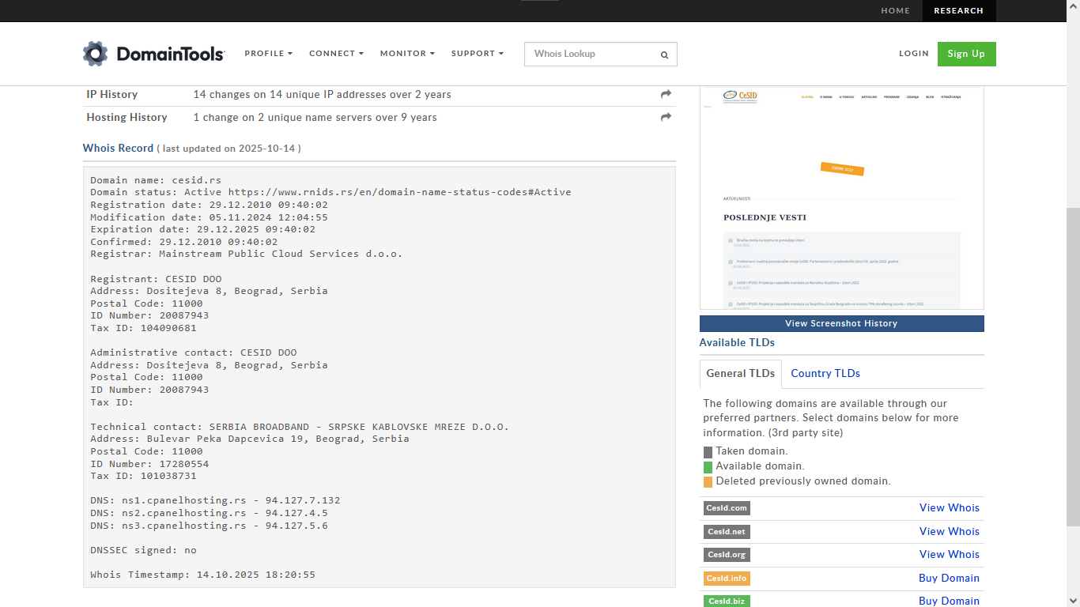
Perform DNS Footprinting
Task 1: Gather DNS Information using nslookup Command Line Utility and Online Tool
Step1: Kloth NSLOOKUP is one Online DNS tool that gives you the info dns name, CNAME, DNS server’s address, unfortunately I got these results.
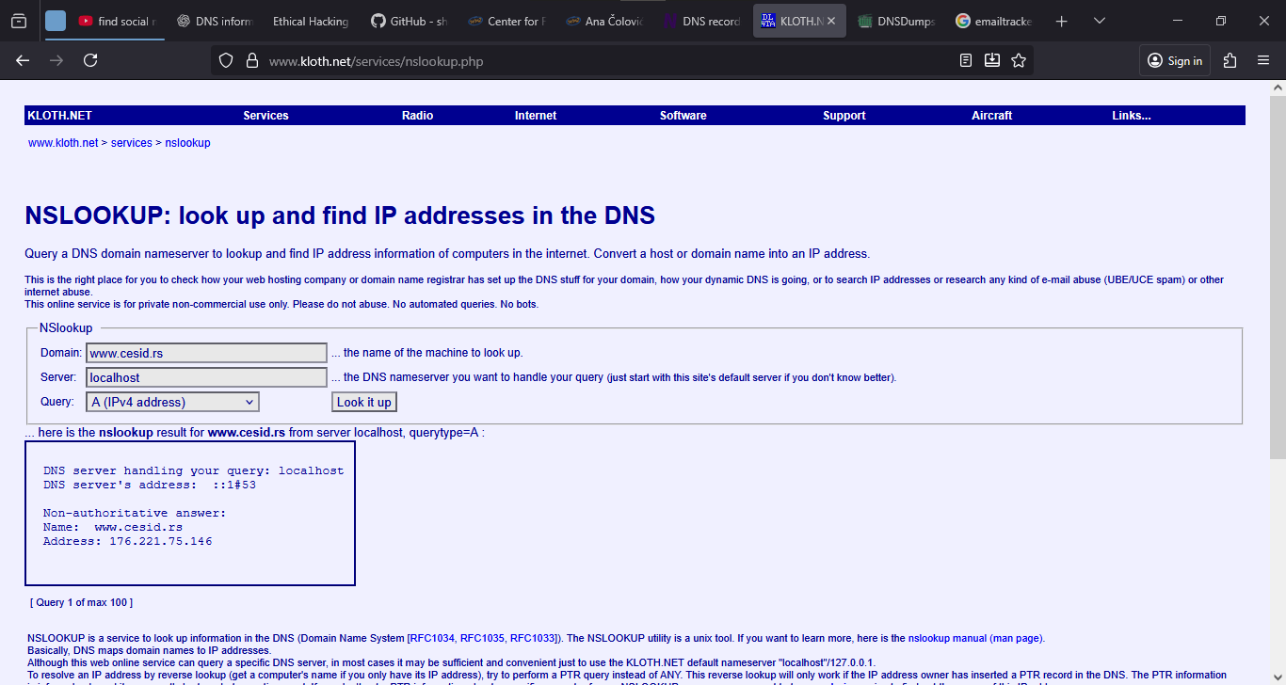
Step2: NSLOOKUP is one of the command line which I used to this lab to gather more info about the target such as Name, IP, NS
